Movement Through the Void
A study of galaxies in support of dark matter

Henry V. Peteet and Alex V. Loomis

Table of Contents:

- Purpose………………………………………………………….……3
- Literature Review ……………………………………………………3
- Methodology…………………………………………………….……7
- Data Analysis………………………………………………………...8
- Conclusions………………………………………………………….13
- Works Cited…………………………………………………….…...14
- Acknowledgements …………………………………………………16

- Purpose:

We plan to show evidence of dark matter through observation of discrepancies between the predicted Keplerian galactic orbits and the corresponding real data. We hope to also investigate the distribution of this dark matter.

- Literature Review:

Dark matter was first hinted at by Jan Oort and Fritz Zwicky in the early 1930’s. Oort observed the motion of the stars in the Milky Way and predicted the presence of more matter in the galaxy than any other astronomers had conceived of. To make this prediction, Oort calculated the rotation velocities of stars that moved near the galactic plane, and found that the stars should be escaping the gravitational pull of the known and visible matter in the galaxy because they were moving so quickly. He stated that there were two explanations for this phenomenon: more unobservable mass in the galaxy kept the stars from leaving orbit, or his rotation velocity calculations for these stars were incorrect (Garrett, 2011). Zwicky’s experimentation was quite similar to that of Oort, but with new mathematical formulas. He used what is known as the virial theorem to find the mass of a given galaxy cluster. Coming to the same conclusion as Oort did on a larger scale, Zwicky found that the standard measurement of the mass of a star cluster (agreed upon by previous science) would only account for approximately 2% of his calculated mass. The rest of the matter was unseen, or nonluminous, and Zwicky then coined the term ‘dark matter’ in German - dunkel materie (Primack, 2009).
After Oort and Zwicky made their discoveries, it wasn’t until 40 years later that Vera Rubin and her team led a study of rotation curves of galaxies that advanced the evolving concept of dark matter. Assuming that each of the stars in the given galaxy would act as if they were planets in a solar system, she employed the formula for the velocity of a body at a certain radial scale outward from the central bulge of the galaxy, where most of the visible mass is concentrated. These Keplerian equations showed that a rotating body’s velocity and the radial scale were inversely proportional because the rotating body’s velocity should decrease as the radial scale increases. However, Rubin’s data showed discrepancies in the predicted, calculated rotational velocities and her observed ones. The rotation curves for the stars in their observed galaxy continued to increase and approach a limit. She concluded that the mass of a galaxy is not concentrated in the bulge, as many astronomers thought before her, but all around them in a halo (Garrett, 2011). Around the same time, a new way to learn more about dark matter’s distribution and size was discovered. Gravitational lensing, a result of Einstein’s Theory of Relativity, utilized the concept that light bends around a mass when it gets close because of the gravitational pull. First used by astronomer Dennis Walsh and collaborators in 1979, he found that they were seeing a double image of the object they were observing. He concluded that this must be because a closer object with a larger mass is causing a distortion (Garrett, 2011). It was later understood that this mass calculated from the gravitational lensing was much larger than the mass that could be inferred from the luminosity of a cluster, or by the visibility of the cluster - yet another pointer to dark matter. It wasn’t until 1984, however, that the Cold Dark Matter theory was proposed, and it was fully accepted by 2000 (Primack, 2009).
As soon as astronomers and physicists began to accept the theory of dark matter, the obvious question to answer was in what form did dark matter appear. From the evidence already gathered, it was known that dark matter formed in loops around the bulges of galaxies, called dark matter halos. But then came the question of what dark matter was actually made of. At first, there were two candidates for dark matter: MACHO’s, Massive Compact Halo Objects, and WIMP’s, Weakly Interacting Massive Particles. MACHO’s were usually large bodies, such as black holes, which contained a lot of mass but could not be visually detected by their luminosity. Unfortunately, MACHO’s were deemed to be an unfit candidate simply because the proposed MACHO’s (black holes, Jupiter-sized planets, etc.) could be accounted for by observation of the galaxy if they were to blame for the extra mass, and scientists had seen that the galaxy was not mostly black holes or mostly Jupiter-sized planets or any combination of other MACHO’s. The concept of MACHO’s as an explanation for dark matter was soon left behind in lieu of WIMP’s, which held more promise. Though most candidates for WIMP’s are unable to be detected, the current viable WIMP is the neutrino, which is a quite small, neutrally charged particle. Scientists already know that neutrinos are plentiful and contain energy. Current mass estimates place the neutrino at filling at most a few percent of the mass of all the dark matter necessary in the galaxy (Mahapatra, 2012). However, many astronomers and physicists are making it their mission to find ways of detecting new WIMP’s and solving the mystery of dark matter.
One group of astrophysicists attempting to learn more about dark matter is NASA. Using the method of Gravitational Lensing, they have gathered data from a sub-sample of 10 galaxies and used it to calculate the rotational velocities for stars in each galaxy along the radial scale out from the bulge of the galaxy using Newtonian and Keplerian formulas (Begeman et. al., 1990). With this information, the data without dark matter, and the actual observed velocities in these 10 galaxies, they formed graphed curves to distinguish the discrepancies between them. The rotation curve of the calculated velocities increased quite quickly and then tapered off while decreasing. The rotation curve that accounted for dark matter increased quickly as well but instead of decreasing, it remained relatively flat and appeared to approach a limit. We used this method of graphing rotational velocities in our project to compare a randomly generated galaxy without dark matter to a generated galaxy with dark matter. In this way, we were able to compare the results of our project with those of NASA, though our methods for acquiring the data were different.

- Methodology:

Please note that for this entire project we wrote the code to analyze the data and build the model; it was not a downloaded or pre-written code of any form.

- Create a body class
  - the creation of a new class type will allow elegant and versatile code to created, and allow a simple way to save all data in a single place for each body
  - storage of:
    - mass
    - velocities
    - position
- Simulate acceleration due to gravity Code
  - will allow us to compute acceleration between two bodies over a timestep
- Simulate movement from acceleration Code
  - uses velocity stored in the body class to move the body a distance in a timestep
- Combine steps 1-3 to move bodies in a timestep with gravity
  - this will allow us to move bodies through gravitational fields and see realistic results
- Test the system in step 4 by simulating the movement of the solar system
  - use realistic masses and velocities to simulate movements and allow for troubleshooting
- Create an orbit velocity function
  - will allow the user to set the body velocity to an orbit velocity around a center mass
- Create a Kuzmin disk system for generating random bodies
  - utilize the Kuzmin disk equation to generate masses of disks which will then create the correct distribution of mass at the appropriate radii
- Combine steps 1-7
  - this will generate a random galaxy with the correct realistic input and set all the bodies to orbit correctly
- Add animation for all the bodies and movement
  - this will allow a video to be shown while the program is running via the VPython module
- Render and plot the velocity curve
  - add in functions to render the frames and measure the velocity at different radii
  - this will allow us to visualize the data in galaxy form and in the form of a velocity graph
- Write dark matter compensation code:
  - add in functions to figure out how much dark matter was needed
  - create the dark matter needed
- Plot the dark matter distribution

- Data Analysis:

We computed many values along the way to test the accuracy of our simulation. This included adjusting the value of the radial scale length, mass, and central mass to match other galaxies such as the andromeda galaxy. When testing gravity we made sure that our calculations were correct by simulating the solar system, and used it to show the accuracy of the system.
The ultimate visual show of our accomplishment and the massive scale of the project was the animation (see figure 1). This allowed us to view and confirm the predicted movement of the stars around the center of the galaxy. We were also able to clearly see the difference in orbit velocities of outer stars opposed to those closer in. This allowed us to observe the obvious bulge in the center that accounts for a large portion of the mass in the visible galaxy.
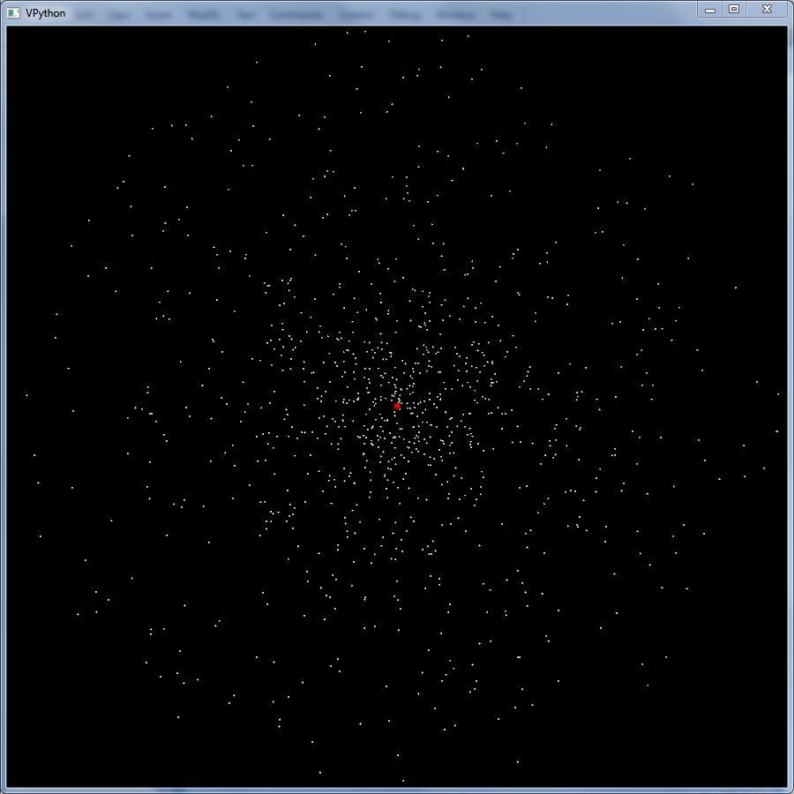
Figure 1: Rendered Frame from Animation

Despite the massive testing that we did, the majority of the useful data came in the form of the velocity curve (see figure 2). This curve was a set of data points that corresponded to the 1,000 to 10,000 points that we rendered in different simulations, but there were no discrepancies between the 1000 and 10,000 point graphs as both had more than the needed number of points to recognize the shape.

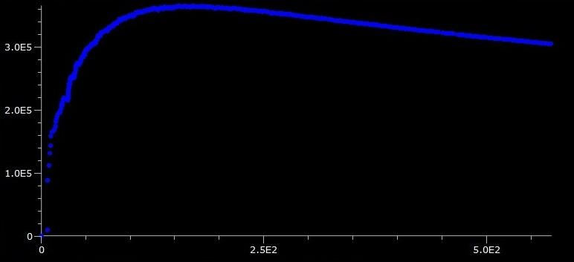

Figure 2: Predicted Velocity Curve

This was the most useful result as we were able to compare the predicted velocity to the actual velocity curve that NASA had created from observed data seen below.

As you can see on the next page in Figure 3, the actual velocity curve remains stable while the model tapers off. The increased orbit speed can only be created in the model by adding more mass, and so it stands to reason that there is in fact unseen mass hiding in the galaxies.

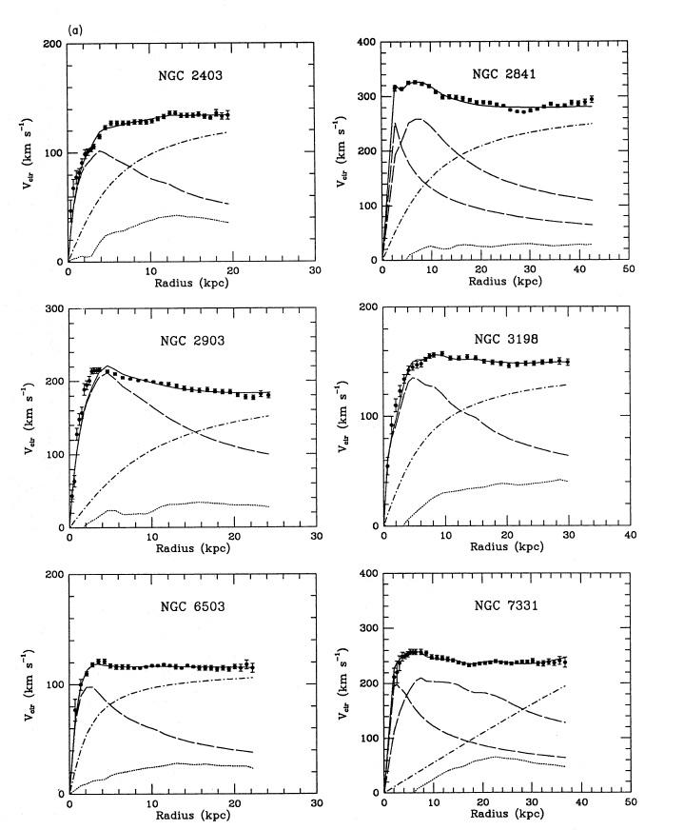

Figure 3: Velocity Graphs from NASA

After simulating a galaxy without the presence of dark matter we proceeded to add in calculated amounts of dark matter to compensate for the missing mass. This process revealed a new view of the galaxy (seen in Figure 4) and a dark matter distribution (Figure 5).
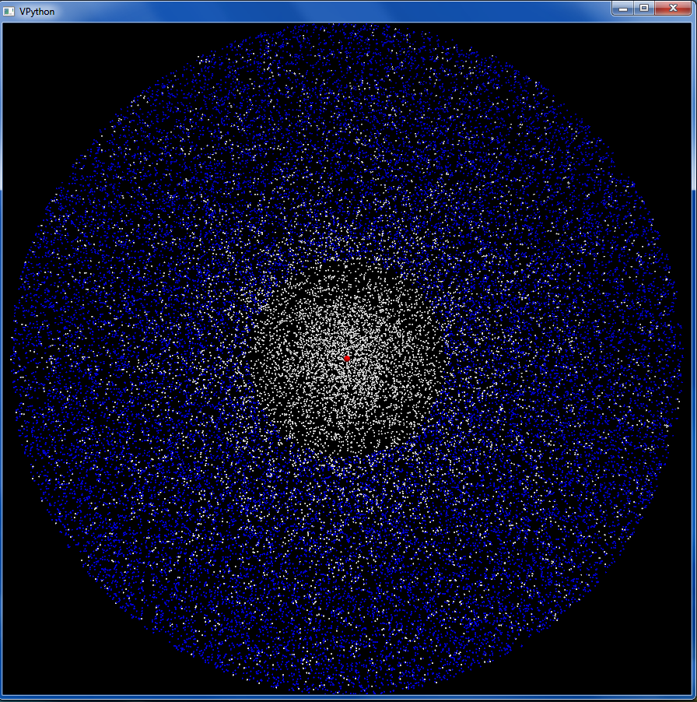
Figure 4: the generated galaxy with dark mater compensating for the lack of visible matter (dark matter in blue, visible mater in white)
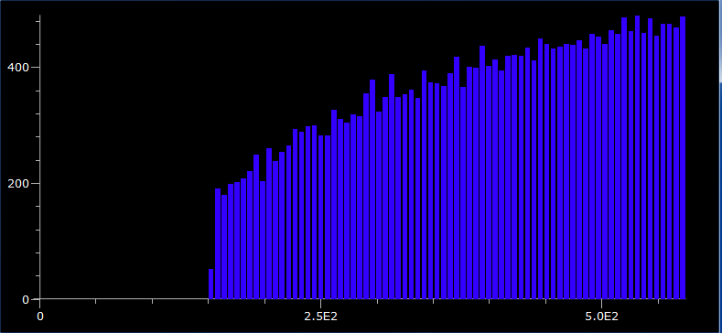
Figure 5: the distribution of dark matter (amount of dark matter vs. radial distance)

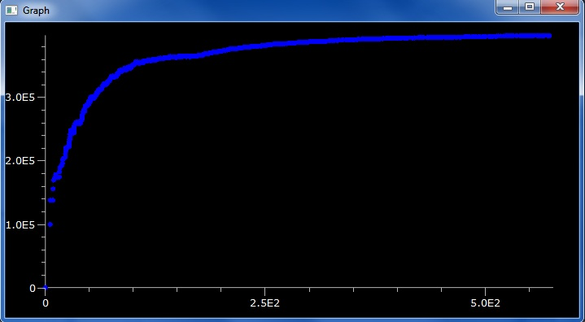
When the dark matter was added to the simulation we obtained a more realistic velocity graph seen below in Figure 6.
Figure 6: New velocity graph after dark matter was added.
- Conclusion:
Our models showed that there was a need for dark matter in galaxies, affirming our statement of intent. The models predicted the movement of stars within the galaxies accurately, according to the Keplerian model, while the real data contradicted the model; this gave us evidence for dark matter. These models were accurate: the data collected from them matched professional work from NASA. The most significant takeaway was the difference in the velocity curves of galaxies. While our velocities began to fall shortly after the radius exceeded the dense central bulge of the galaxy, the real curve remains constant and does not taper off. This is astounding considering that once the radius is beyond a majority of the galactic mass, the velocity should decrease consistently. This proposes a new view of galaxies constructed of small amounts of visible matter, surrounded by immense clusters of dark matter that maintain the outer orbit velocities. From measuring this distribution we can observe that dark matter exists more frequently in outer regions of galaxies.

- Works Cited:

(2007) "Galaxies." McGraw-Hill Encyclopedia of Science & Technology. New York: McGraw-Hill. Print.
Begeman, K. G., A. H. Broeils, and R. H. Sanders (2012), "Extended Rotation Curves of Spiral Galaxies: Dark Haloes and Modified Dynamics." NASA Astrophysics Data System.
Garrett, K., & Duda, G. (2011). Dark Matter: A Primer. Advances in Astronomy, 2011, 1-19.
Mahapatra, R. (2012). Review of Dark Matter Direct Detection Experiments. Pramana - Journal of Physics, 79(5), 1045-1057.
Mo, H. (2011). The Link Between Galaxies and Dark Matter. International Journal of Modern Physics, 20(10), 1771-1777.
Moore, Patrick (2003) Astronomy Encyclopedia [an A-Z Guide to the Universe]. New York: Oxford UP. Print.
Primack, J. (Director) (2009, January 12). A Brief History of Dark Matter. Galaxy Seminar. Lecture conducted from UCSC, Santa Cruz.
Porcel, C., F. Garzon, J. Jimenez-Vicente, and E. Battaner. (2008) "The Radial Scale of the Milky Way." Astronomy and Astrophysics: 1-5. Print.
Ridpath, Ian, (2001), The Illustrated Encyclopedia of the Universe. New York: Watson-Guptill Publications. Print.
Schwarzmeier, Jakub. (2007) "On Simulations of Galaxy Dynamics and Their Application to Physics Education." Diss. University of West Bohemia in Pilson, Print.
Sutherland, Will. (2012) "Rotation Curves." Reading. The Galaxy. 27 Apr. 2012. The Galaxy. Web. <http://www.maths.qmul.ac.uk/~wjs/MTH726U/>.
Tamm, A., and P. Tenjes. (2003) "Structure and Mass Distribution of Spiral Galaxies at Intermediate Redshifts." Astronomy and Astrophysics 403.2: 529-36. Print.
Watkins, Laura L., N. Wyn Evans, and Jin H. An. (2010) "The Masses of the Milky Way and Andromeda Galaxies." Monthly Notices of the Royal Astronomical Society: 1-15. Print.
Zonoozi, Akram Hasani, Andreas H. W. Küpper, Holger Baumgardt, Hosein Haghi, Pavel Kroupa, and Michael Hilker.(1998-2001) "Direct N-body Simulations of Globular Clusters - I. Palomar 14." Monthly Notices of the Royal Astronomical Society 411.3 (2011): Print.

- Acknowledgements:

We would like to thank Dr. Schatz for meeting with us early on in the process of our project and his valuable input on the modeling of galaxies. In addition, each of us would like to thank our parents who let us stay up late coding, and our teacher Mr. Nichols who turned us onto the idea of working with the stars.

